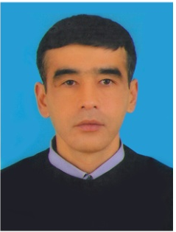 KOMOL MIRZAYEV
PERSONAL DATA
Date and place of birth: 23 July 1970,Tashkent, Uzbekistan
Country of residence Uzbekistan
Nationality: Uzbek
Marital status: Married
Current location: Tashkent, Uzbekistan
CONTACTS: Tel : +99890 3244610;
E-mail: kamolmir@list.ru
EDUCATION AND QUALIFICATION
From 1985 to 1990  From 1990 to1995 | Oriental miniature paintings, Art college of P. P. Benkov Tashkent,Uzbekistan  Graphic Art Faculty, Tashkent State Pedagogical Institute, Uzbekistan
WORK EXPERIENCE
As a Master in oriental miniature painting
From 2009 up to present
The Center of national decorative applied art “Zeb ichra ziynat”, Tashkent, Uzbekistan

As a Master in lacquer miniature
From 1990 to 2009
Research and Production Center “Musavvir”
Tashkent, Uzbekistan

SKILLS
Languages: Uzbek, Russian
AWARDS
The first Award “International Muscat Festival 2012”, Sultanate of Oman

PARTICIPATIONS
“International Muscat Festival 2012”, Sultanate of Oman on February 2012
“Art and Craft Trade Fair” Lillestrom, Norway on October 2011
“Nara Anniversary Exhibition” Nara, Japan on February 2010
“Uzbekistan national cultural days” Paris, France on April 2007
“Uzbekistan national cultural days” Paris, France on April 2007
“Human and Nature Exhibition” “World Expo 2005” Aichi, Japan on August 2005
“Art Days Exhibition”, Center house of Artists, Moscow, Russia February 2003
“Oriental Culture” Exhibition, Museum of archeology, Trier, Germany on August 2002

OTHER
From 2000 year member of “Artists Academy of Uzbekistan

WORKING PROCESS OF A MASTER IN
ORIENTAL MINIATURE PAINTING
KOMOL MIRZAYEV
Modern miniature of Uzbekistan is based on the traditions of medieval oriental miniature. Also imaging technology based on the technology of the medieval schools of miniature. For the selection of the plot for the composition taken oriental legends, fairy tales, poems, poetry, short stories, medieval writers and poets. The technology for the preparation of paints based of glue is taken egg yolk. The brightness of the richness of colors used distilled water, water colors and natural pigments. To colorize the fine details of the miniatures uses only squirrel brush and columns brush. For the miniature on the paper also uses paper which is specially prepared from the mulberry tree. Also uses natural gold leaf. Gold is pounded by hand more than six hours. After the application of gold on the miniature gold is polished with wolf tooth. After the drawing of gold on the miniature, gold is polished with a wolf tooth. Since the wolf tooth has a good enamel. Gold attaches miniatures a rich appearance and airiness. Miniature art is passed down from generation to generation. For revival of the scored tradition is based schools of ancient oriental miniatures. And in our Art Center founded a school for teaching young miniaturists. And our miniaturist Kamol Mirzaev teaches young miniaturist secrets of oriental miniature.

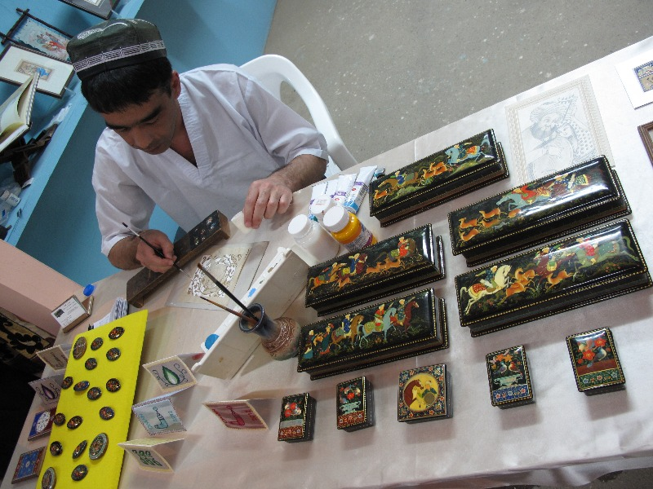

Works of a master in Oriental Miniature Painting
KOMOL MIRZAYEV
