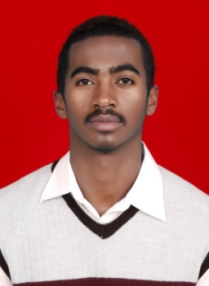
PERSONAL INFORMATION
Full name : FANANANTSOA Jean Eddy (Eddy Bessa)
Date and place of birth : Madagaskar (Ambalavao) 30January 1990
Nationality : Malagasy
Mobile : +62 85 766 540 610
E-mail : jfananantsoa@yahoo.fr
OBJECTIVE
To improve more and more my own talent and have a great hard work and experience in Art
EDUCATION AND QUALIFICATION
Graduated from Madagascar High School 2010
Graduated of Bachelor degree from University of Fine Art ISI Padangpanjang (Painting) 2016
Master degree at ISI Yogyakarta (Painting, sculpture, design) 2016-2018
OTHER SKILLS
Sculpture, design, Art exploration.
EXPERIENCE
4 years experience of working in a workshop painting
3years experience of managing and joining exhibitions
2 years experience of exploration
HOBBIES
Learn new things
Gym, play basketball, boxing, photography.
LANGUAGES
Malagasy
French
English
Indonesia

