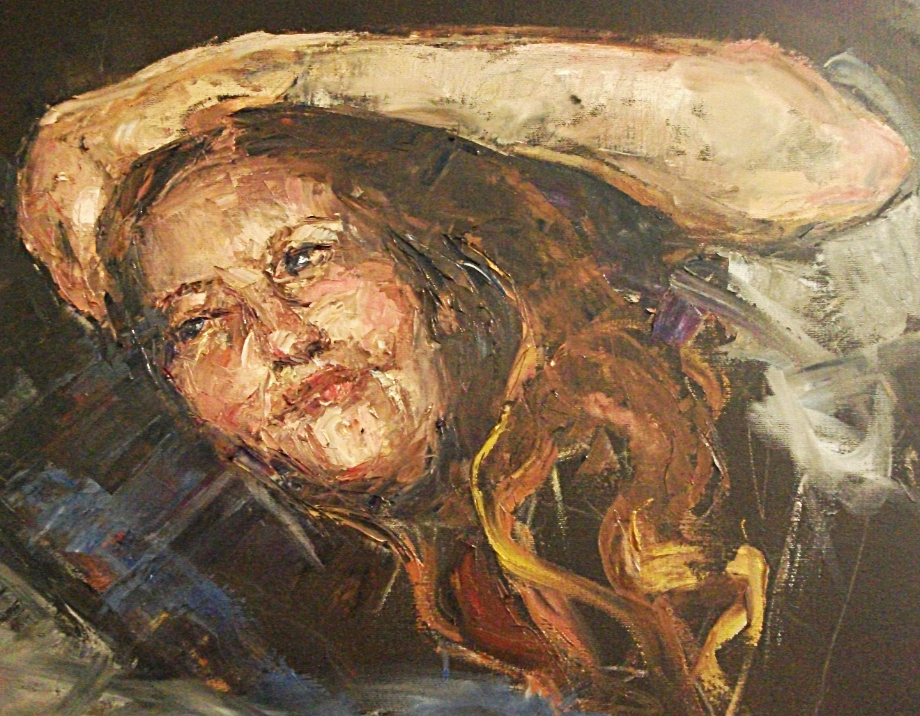

WORK in Oils
  - Self Portrait
Peta Williams | Artist | 2016

Curricula Vitae for Artist Peta Williams .

Student of Julian Ashton School, Sydney from age 16 years to 22yrs
Student of art at Surval College, Switzerland for 24 months, from 17 to 18 years
Scholarship awarded to Lausanne School of Fine Arts at 18 yrs.
Apprenticeship to artist in Tasmania at 24-26 years.
Degree in Law from Tasmania University.
Student of Diploma at Royal Arts Society for last 7 years .
Scholarship awarded from RAS 2012 and 2013,
Awards from RAS in Drawing 2011, 2015, 2014.
Drawing Certificate from WATTS ATELIER USA.
Diploma of Art Royal Art Society

Work
1997-2017 PR and Administration to Biologica Management
2017 Casual Art Assistant Teacher for Life with Art

