press is available for all shows
www.kultursciok.com
facebook/kultursciok
Alessia Siniscalchi lecturer position
Reference contacts info
Sylvaine Guyot
Department of Romance Languages and Literatures
Boylston Hall, 4th floor
Harvard University
Cambridge, MA 02138

Mon email pro:
guyot@fas.harvard.edu

Judith Grodowitz, M., AmSAT
The Alexander Technique
William Esper Acting Studio, NYC
Mannes Music College, New School Univ., NYC Judith Grodowitz
337 West 21st Street, #5A
NY, NY 10011
phone: 646-338-2152

Snaporazverein art and video production

Federica Maria Bianchi federicamaria.verein@gmail.com
Sur Puoz 14, 7503 Samedan GR - CH
http://www.snaporazverein.com/
www.kultursciok.com
facebook/kultursciok live art collective
vimeo https://vimeo.com/user9314760

alessia.siniscalchi@gmail.com
info@kultursciok.com

alessia siniscalchi works as an actress curator, producer , director.Graduated in law and lawyer, she has been studying theater with different professionals.In 2002 she won an important scholarship and grant to attend the Actors Studio in NYC where she graduated in 2005.Her teachers:Elizabeth kemp,joe ragno, nova Thomas,Barbara poitiers,susan aston ,Elisabeth swados and many others . Theatre projects include, Rose tatoo by Tennessee Williams,Three penny Opera,the musical the three gods directed by Elisabeth Swados in nYC and Social Insecurity at theatre for the new city in NYC. Lately she directed the play Scarlet Coffe in Turin ,a musical work which is coprodUced by Festival Colline Torinesi in 2012/2013 ; in 2014 she presented the bilingual show dancing prohibited at the Napoli teatro festival in Naples . in 2016 the performance I HAVE BURNT IN YOUR EYES .I BURN inspired by the film Paris Texas, the musical ladri di prosciutti ( HAM THIEVES ) a musical , around the universe of Federico Fellini
She is working in Paris in the prestigious La Menagerie de verre, in order to create a multidisciplinary performance, Medea’s visions with artist Valerio Berruti . She is living in between San Francisco and Paris.
She founded kulturfactory a contemporary art multidisciplinary residence where 6 times a year she hosts artists from allover the world in order to create art and theatre work and to go toward the creation of a festival dedicated to multidisciplinary art
She teaches in schools and to professional actors in partnership with afdas, adami and different institutions ;
She is planning to collaborate in San Francisco with some American artists she met during her studies in NYC

She is actually living in Paris where she studied with Ariane Mnouchkine and then she participated at the show Sortie 27 a Nanterre then she performed with some important contemporary theater companies and artists such as ricci forte , alberto sorbelli and she kept developing collaborations for her work .In Paris she was involved in social projects in Hospitals , Retirement houses and Universities all over Paris. She created the performance Besides Closed doors, She wrote the play dancing prohibited, the performance I have burnt in your eyes , I burn,inspired by the wim wenders film paris texas , she produced the video Medea Vision a project to be finished and completed in 2018 , and multiple ateliers and social and political plays. As a curator she founded a factory close to naples where she is starting a new festival .All these projects have been presented in various festival . With the dancer Ivana Messina she founded kulturscio’k and she works constantly in between France and Italy linking people from different backgrounds for international collaborations in different projects she directs or produces. she cooperates with artists from NYC, Italy, France, South America, all of them involved in different aspects of performing arts.

Shocking art through art

What is Kulturscio’k?

Kulturscio’k is an independent theatre company dedicated to developing and producing artistic expressions (video, theatre, performing arts) which reflect the communities in which we live and those we pass through termporarily The main concept of the group is to blend traditional and classical work with experimental and contemporary styles and visions, working collectively with artists and people from different backgrounds with different perspectives.

Kulturscio’k is dedicated to producing work that helps to keep alive independent art and cultural heritage around the world. We promote collaborations and the development of new proposals, opening our vision towards new dramaturgical works and styles. We propose original performances juxtaposing classical and contemporary texts, and visual sound and impulses inspired by our daily life.

Our theatrical workshops, “kultur labs”, host internationally renowned artists and are focussed on the exploration of each participant’s talent and his or her expressivity among the others. We have an approach that is flexible and open to different creative possibilities.

Our co-operation with people from different countries – thus far the USA, the UK, Italy, France, Spain, Germany, Bangladesh and Brasil – represents an important strength. The company is truly international. Kulturscio’k was created in 2007. In the two years since then the company has created / participated in various national and international collaborations exploring various artistic languages in the fields of theatre, dance, music, video and site specific

Kulturscio’k was created in 2007. In the years since then the company has created / participated in various national and international collaborations exploring various artistic languages in the fields of theatre, dance, music, video and site specific performance:

- “Beside Closed Doors” - Festival Teatri di Vetro 2008, Rome – a site-specific performance about a person living in an apartment, with the spectator left inside the apartment for a while, visioning her life through a mixture of sounds, installations, poetries and suggestions;

- “Sertao” – a theatrical / dance piece presented at festivals in Turin, Vignale,Piattaforma in 2009;Inside Off dance festival in turin

- Participation in production of “Nueva Cancion”, sponsored by Amnesty International; the first reading was in NYC in may at the Theater for the New City.

- Scarlet Coffee , selected at Rigenerazione Festival in turin and presented the 16 th of june 2011 at the prestigeous Festival delle Colline torinesi 2011

- Dancing prohibited written by alessia siniscalchi presented at the napoli teatro festival in 2014

- J’ai brûlé dans tes yeux. Je brûle , a performance freely inspired by the Wim Wenders film Paris, Texas creation 2016 in collaboration with museo madre institut français et goethe institut PRESENTED AS A PERFORMANCE IN MADRE MUSEUM NAPLES

- Ladri di prosciutti “the Universe of Federico Fellini shaped as an originally written musical show”creation 2017 PRESENTED IN PARIS THEATRE DE LA GIRANDOLE

- Medea’s visions an art theater collaboration with Valerio Berruti; paulina Mikol, Phil St George and many others

KULTURSCIO’K is dedicated to contemporary creation education and production

To

Valorize difference and integration

To look at our society at to talk about what happens through words and artistic expression (Interventions in prisons , or with handicaps, etc)
TO WORK ON CONTEMPORARY REPERTORY

TO CREATE TRANSDISCIPLINARY WORKS

# 0033642811630
contact: alessia siniscalchi
alessia.siniscalchi@gmail.com
www.kultursciok.com

Foto

https://issuu.com/blackspringraphics/docs/brucionapoli2
https://issuu.com/blackspringraphics/docs/brucionapoli1
https://issuu.com/blackspringraphics/docs/brucionapoli3
https://issuu.com/blackspringraphics/docs/brucionapoli3

1.
https://vimeo.com/233848022?ref=em-share
2
https://vimeo.com/233806835
3 video sky
https://vimeo.com/230322097

les voleurs de jambon /
dedicated to Federico Fellini

https://youtu.be/R28Q_l4I8v4

Teaser « Vietato Ballare/Interdit de danser » (1 min)

http://youtu.be/Exe7aEbvJl8

5 min

https://www.youtube.com/watch?v=7AtvS5eRxi4

Création 2011/2013 Festival delle Colline Torinesi
ROUGE CAFEINE/CABARET CONTEMPORAIN
Scarlet coffee
Vidéo Festival Colline Torinesi, 2011 (15 min)

http://youtu.be/4J6PpZ8ckc4

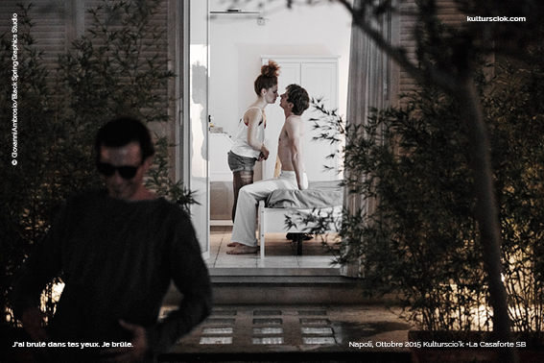

# I HAVE BURNT IN YOUR EYES . I BURN
FREELY INSPIRED FROM PARIS, TEXAS BY WIM WENDERS
After a journey in California I felt that the desert was for me a place of dream and burn, I remember that I read the Truman Capote's book Cold Blood, a masterpiece I have adored, and I suffered from an inclement desire and I wondered if the mystery of this desert and its unlimitedness would have led me far. Today, by watching Paris, Texas, I said to myself: this burn is now within me, in my desert and in our desert, every day, and I would like to talk about it with body strength and theater, and through this film. ALESSIA SINISCALCHI

We have decided to dig into a multidisciplinary work and to create collectively a text, as well as different physical partitions. A dialogue is also settled with plastic art
More on www.kultursciok.com

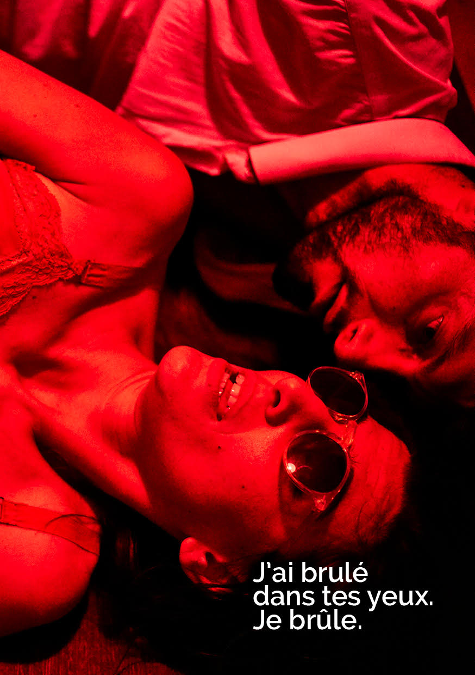

#MEDEA’S VISON
a multidisciplinary art project
with artist Valerio Berruti
live musical
original script by Paulina MIkol
and classical plays by Bernard Shaw, Dario FO, Euripides , Grillpartzer

the first of different visions dedicated to myths

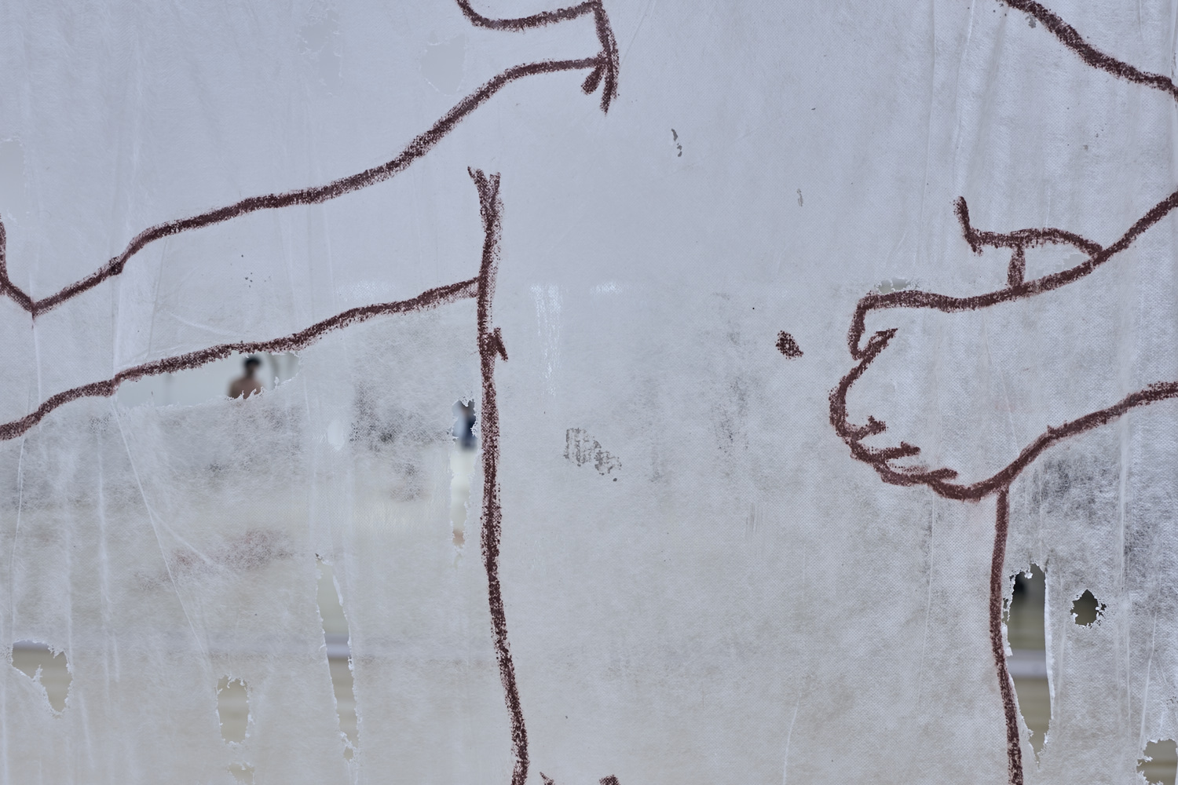

DANCING PROHIBITED / INTERDIT DE DANSER original theatre work with music

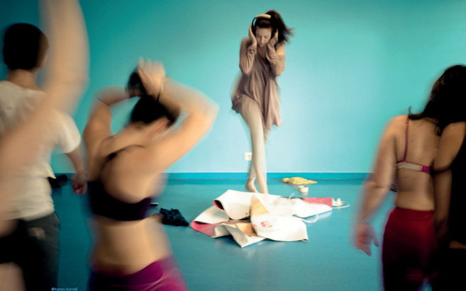

#DANCING PROHIBITED ( full script available)

Cinderella Cattania finds herself catapulted into a courtroom without knowing why. A voice tells her to be silent and to wait for the judge. The poor woman, forced to be there, dances alone to kill time.

~ Dancing prohibited
“They say that dancing here is prohibited.
No one should stop dancing once started.
Maybe we would have understoood each other if instead of thinking we would have been dancing “
Among the rules of the building of the headquarters in Turin Kulturscio'k was written: Forbidden Dancing. From here, a reflection, are we able to dance today? to be free from rules and patterns?
It is the charge of theft of a portrait that moves the story and its characters: three witnesses, a lawyer, a PM, a judge, the accused. An excuse to tell the ambiguous dynamics of justice, freedom continually denied that remains an unattainable ideal and love as lived utopia. Dominant themes: love, eros, society, change, decisions, utopias, dreams. The characters dance and sing in a perverse nonsense that brings almost total incomprehension. The woman charged relates to her judge / prosecutor who finds herself haunted by guilt, unable to decide, self castrated in emotional detention.
The search for his own freedom, becomes the negation of others freedom

#ROSSO CAFFEINA (Scarlet Coffee )
~ contemporary musical with original songs ~

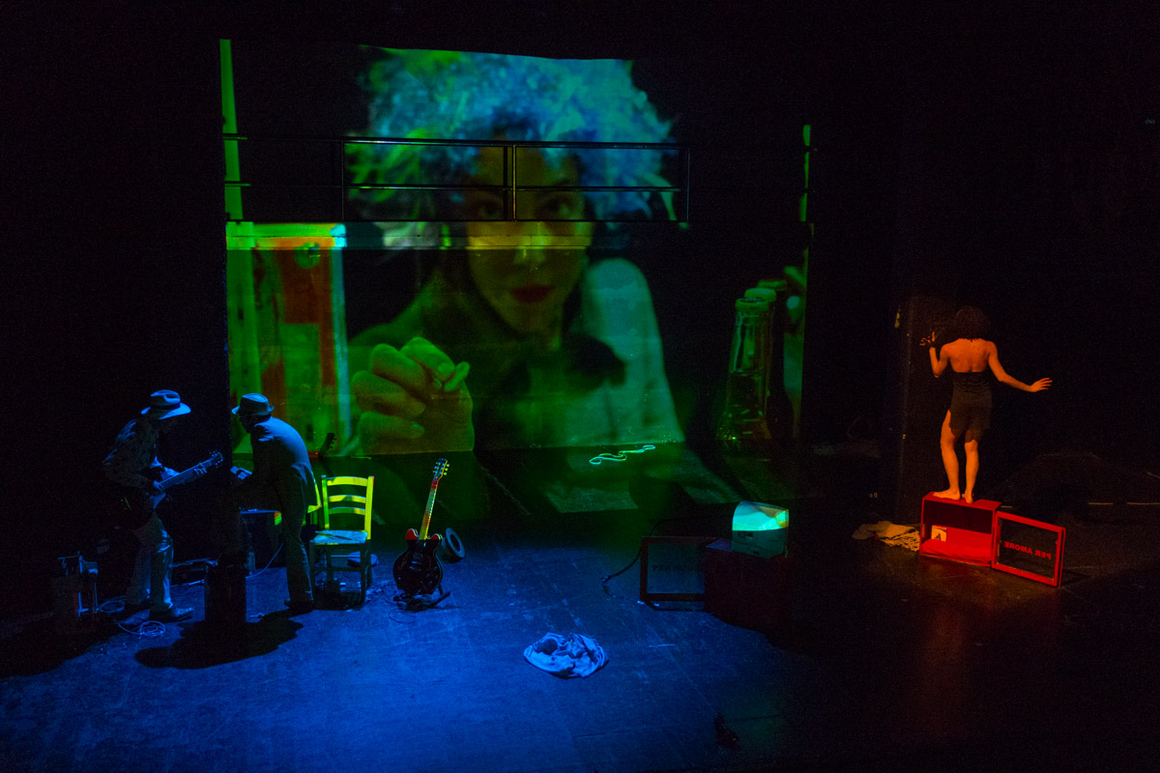

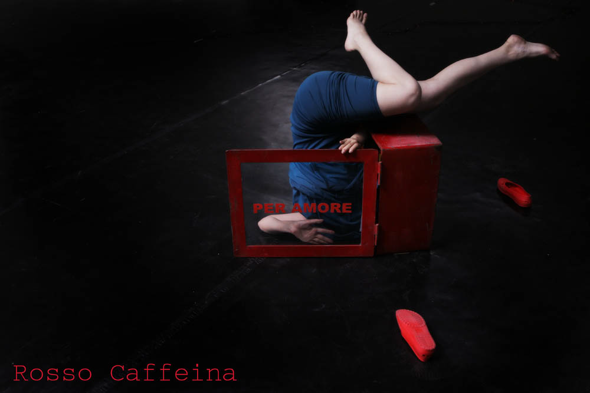

Scarlet Coffee is a drama inspired by poems written by Argia Coppola dramatised through music, dance, song and the spoken word.

It is an original, colourful, moving and ironic trip through the most intimate and secret cravings of a love story that is both intense and mysterious.

#ladri di prosciutti /les voleurs de jambon / a full musical trip in the universe of federico fellini

written by alessia siniscalchi

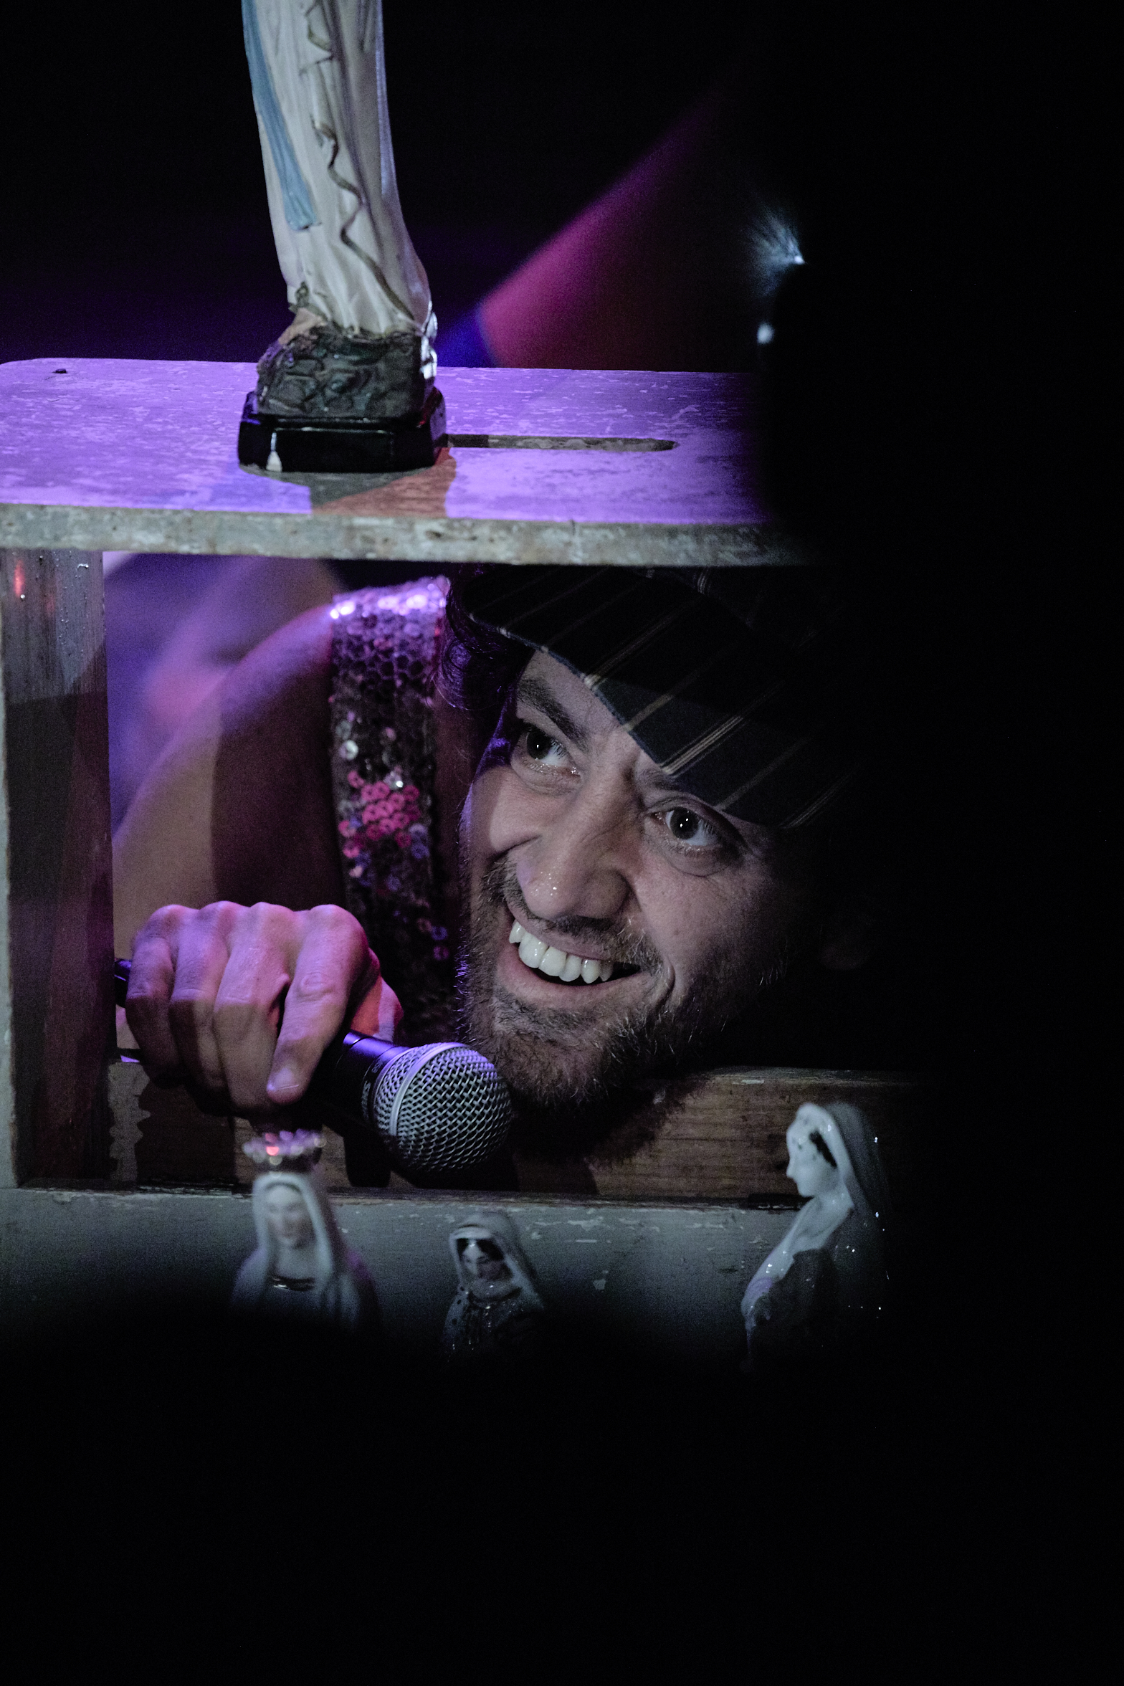

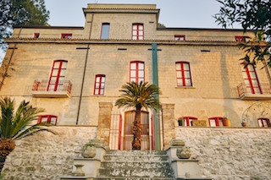

#KULTURFACTORY
a full year long residential art program for creative people from everywhere
construction marvellously restructured in 2014 and built in the beginnings of last century.
Domicella is a small country situated in a woody basin to the borders of the Vallo of Lauro and Nola, almost 35 km from Naples ( 40 minutes by car ).
Dipped in the green Domicella is also characterized by a particularly mild climate. Fresh and windy air in summer, sweet in winter.
Displaced on 3 floors and absorbed in the light with 7 bed rooms , 6 baths and an ample kitchen, the residence can arrive to host up to 13/15 people.
The residence has wireless, apple tv, airplay in the rehearsal room .

