SARA RAHANJAM
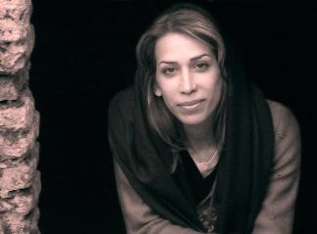
1984 - Born in lahijan, Iran
Lives and works in Tehran, Iran
Education
2007 - BA of sculpture From Fine Art, Tehran university
Group Exhibitions
2011- Group Exhibition Under 35 years , Fravahr Gallery , Tehran
2011 - Group Exhibition Ivan Sepid, Karaj
2010 - Group Exhibition Under 35 years , House of Artists , Tehran
2009 - Group Exhibition, SMALL SCULPTURES, House of Artists, Tehran
2008 - Group Exhibition, The First Iranian Annual Sculpture EXPO, House of Artists, Tehran
2006 - Group Exhibition painting and Mask , Lahijan
Award
2010 – National Festival Urban Space – Mashhad
2010 – Making Martyrs Statue – Ahvaz (Second Winner)
2010 - The 6th Festival visual art , Shiraz (First Winner)
2009 - The 5th Festival visual art , Shiraz (Second Winner)
2009 - making martyrs statue - HAMEDAN (First Winner)
2008 - National Fine Arts Company festival Imam Reza , Shiraz (Third Winner)
2008 - The 4th Festival visual art , Shiraz (First Winner)
Biennials
2010- the 2st international biennial Mediteran in Krovat
2008 - The 1st Sculpture Biennial for Urban Space, Barg Gallery, Tehran
2009 – The 2st Sculpture Biennial for Urban Space, Barg Gallery, Tehran
Symposia
2006 - 1st Sand sculpture symposium, Babolsar, Iran
Professional Qualifications
Permanent Member of the Society of the Iranian Sculptors
Member of the Exhibition Committee of the Society of the Iranian Sculptors
2009 - responsible for the festival's first international arts festival students, Tehran

