Personal artistic statement:
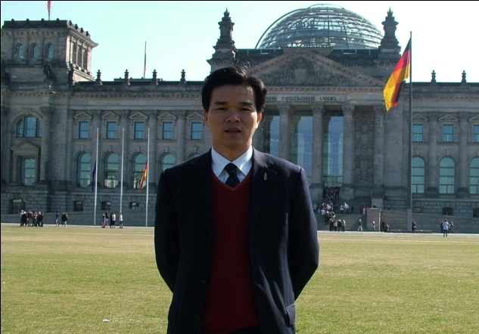
Wenqin Chen was born in 1979 in Fujian, Zhang Zhou, where he studied at the Art & Design School of Fuzhou University during 1995-1999. In Sep. 1999 he studied at the Academy of Art and Design, Tsinghua University in Beijing before going abroad for a MA degree at the Winchester School of Art, Southampton University in UK. Since 2007 he has been teaching in University. His academic pursuit, he bases in the Chinese culture and pursue an understanding of the western world and its culture with a main focus in European modern art.

Since 2000's, Wenqin Chen has used Chinese calligraphy, sculpture and installation to explore the relationship between life, art and their diversity. He created the work "Human Civilization, Spirit and Strength" (2004 MA final degree show). The beings of life, the analysis of our current living environment tensions and the wonder of the human experience have set Wenqin’s intellectual inquiry. He explains: "When we recognize this resource of life, we will then cherish it.”He also uses some readymade directly into his own artistic forms, through combination and installation showing its meaning. The representative art works of this period are: “Speciment” (2007), “Hot Bed” (2007) and “Up Side Down” (2007) which won the runner-up of the annual competition at British Saatchi Gallery in 2009, etc.

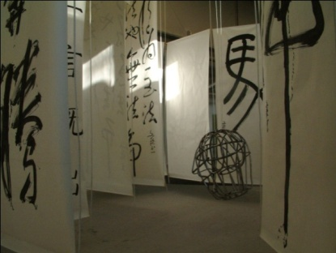
Work Title: Human Civilization、Spirit and Strength
Medium: paper, ink, wood, stainless steel, ropes.
Dimensions:L:800cm/W:800cm/H:450cm
Date:2004
Private collection Southampton

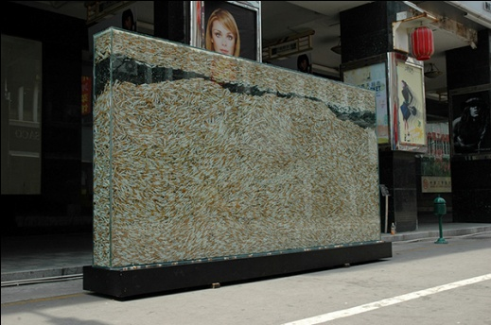
Work Title: Specimen
Medium: cigarettes、toughened glass、resin、stainless steel
Dimensions:L:400cm/W:60cm/H:220cm
Date:2007

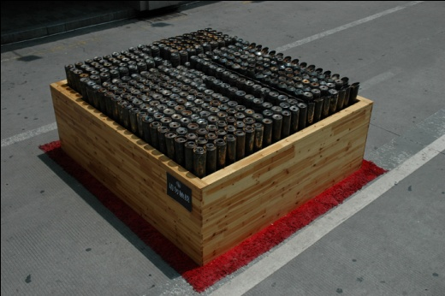
Work Title: Hot Bed
Medium: motorcycle exhaust pipe、wood、rug
Dimensions: L:250cm/W:230cm/H:90cm
Date:2007

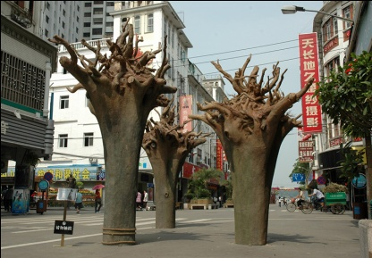
Work Title: Up Side Down
Medium: bronze、rope
Dimensions: L:500cm/W:500cm/H:450cm
Date:2007
Collection: Art organization London

While contemplating the origin of life, Wenqin Chen became fascinated and inspired by the forms of the human baby and created a series of works inspired by it. As an example, the instalation of work "Your Turn"(2008), he explained: "The great life is growing in the competition,”and the “Life Posture”.During the following year (2009), he created the work of “Standing Egg” which realized his thought: "Can we then push the thinking of the origin of life forward? Thisthought advances our understanding of the life cycle and distills its meaning with the simplicity of an embryo.” For all of time, the egg and the embryo are the most enduring and significant beings existents and are at the basis of perpetuating life itself. As a source of inspirationand research Wenqin Chen studied extensively the human body, various scientific journals and statements, real life examples, and countless images. Examples are illustrated in the series of works“Before a baby comes out of its mother's body” (2011-2015) and "Beautiful Evolution" (2013-present).

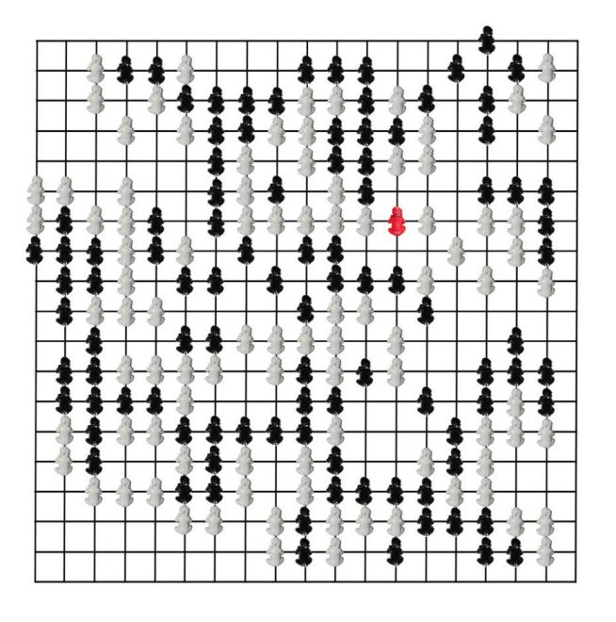
Work Title: YourTurn
Medium: bronze
Dimensions: L:800cm/W:800cm/H:14cm
Date:2008

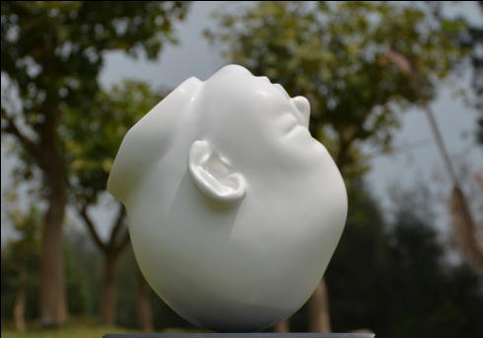
Work Title: Life Posture
Medium: bronze
Dimensions: L:161cm/W:175cm/H:200cm
Date:2008
Private collection London

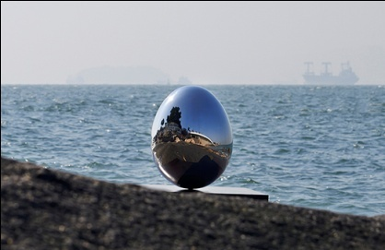
Work Title: Standing Egg
Medium: stainless steel
Dimensions: L:153cm/W:153cm/H:200cm
Date:2009
Collection: Art organization Paris

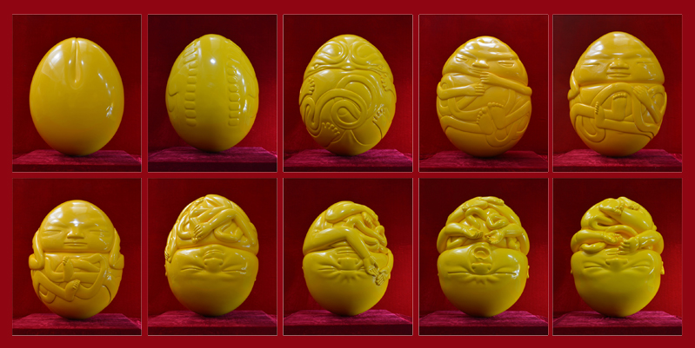
Work Title: Pregnancy - Before a Baby Comes out Of Its Mother’s Body
Medium: bronze
Dimensions: L:52cm/W:52cm/H:68cm (for each piece)
Date:2011-2015

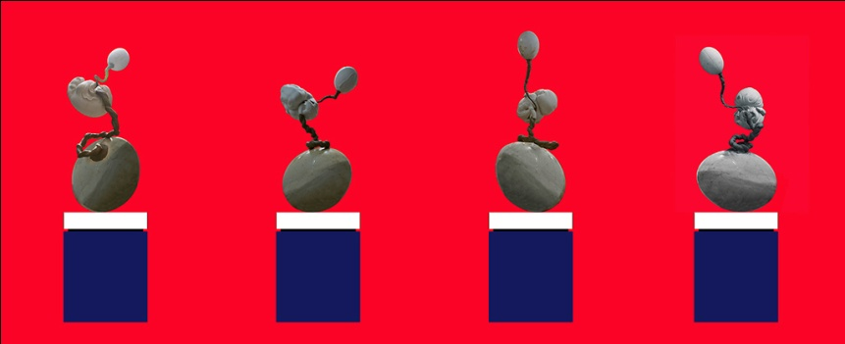
Work Title: Beautiful Evolution– In Second Month
Medium: bronze
Dimensions: L:56cm/W:52cm/H:152cm （for each piece）
Date:2013-present

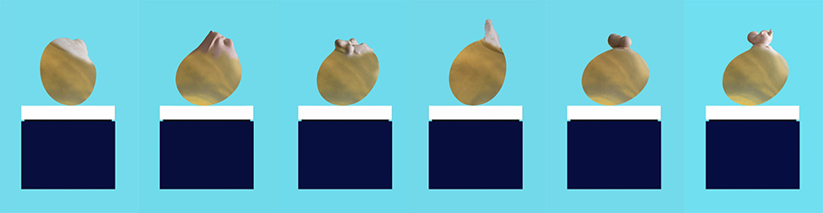
Work Title: Beautiful Evolution– Childbirth
Medium: bronze
Dimensions: L:80cm/W:80cm/H:57cm （for each piece）
Date: 2012-present

In analyzing the life body with its infinitepossibilities, Wenqin Chen’s subject of enquiry emerged. Of equal importance, he is passionate about the dialog created between the positive and negative spaces that surround his work. As a way of expressing “the energy of space,” he emphasizes the momentum of the object to symbolize life’s release or “birth,”while extending the implied energy field to its largest range. The representative works are: "pregnant" (2001), "Endless Curve" (2009)(which won the Public Speaks at the Broomhill National Sculpture Prize 2011 in UK), "Moving" (2012), "Expanding" (2014), "Water Drop" (2014), "Story Beginning" (2015) and a series work of "Be in Here" (2015).

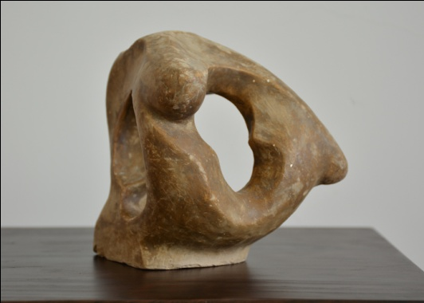
Work Title: Pregnant
Medium: clay
Dimensions: L:13cm/W:12cm/H:13cm
Date:2001

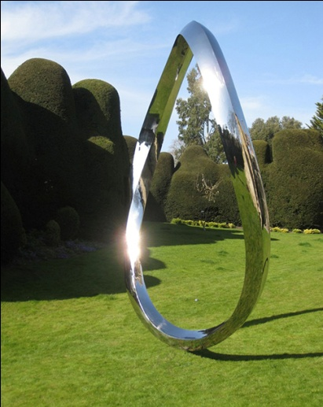
Work Title: Endless Curve
Medium: stainless steel
Dimensions: L:236cm/W:145cm/H:380cm
Date: 2009
Private collection London
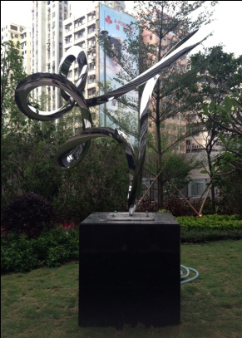
Work Title: Moving
Medium: stainless steel
Dimensions: L:295cm/W:154cm/H:300cm
Date:2012
Collection: Kowloon, Hong Kong

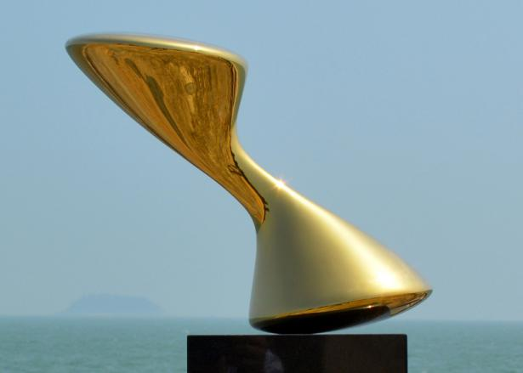
Work Title: Expanding
Medium: stainless steel
Dimensions: L288cm/W144cm/H230cm
Date:2014
Collection: Arab National Bank

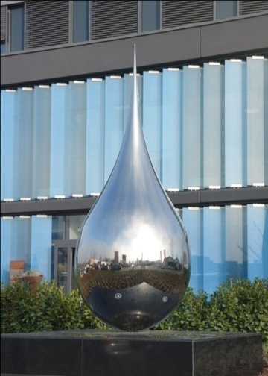
Work Title: Water Drop
Medium: stainless steel
Dimensions: L150cm/W150cm/H375cm
Date: 2014
Collection: Heidelberg Germany

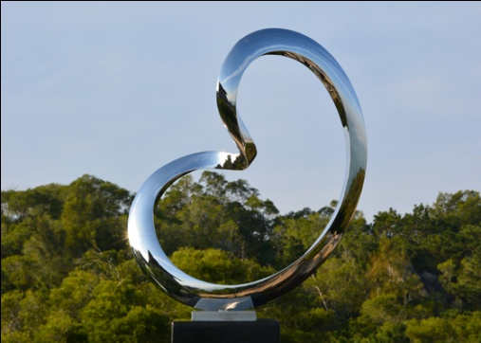
Work Title: Story Beginning
Medium: stainless steel
Dimensions: L:116cm/W:52cm/H:130cm
Date:2015

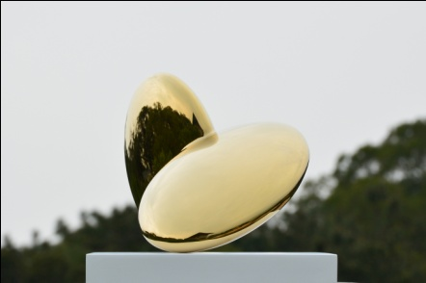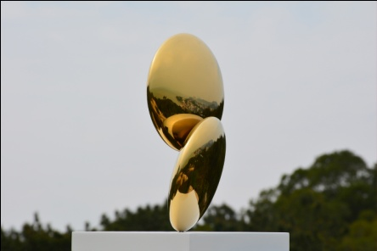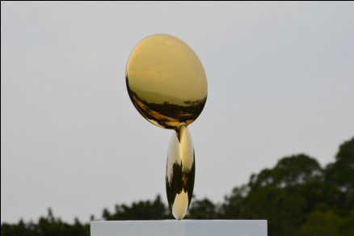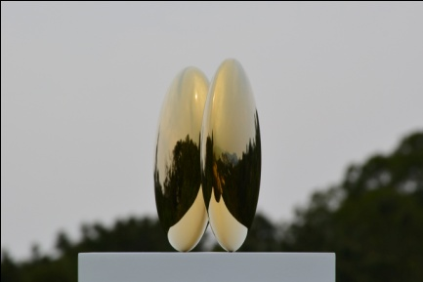
Work Title: Be In Here
Medium: stainless steel
Dimensions:L:320cm/W:210cm/H:200cm,L:320cm/W:210cm/H:200cm,
Date:2015
Private collection London

Within his exploration of the life, the egg is reduced into its essence as atoms, molecules, or cells. When combinedwith things or objects, a physical or chemical reaction occurs which has been the basis for these sculptures: “Is it mine”? (2013-2015),“Kissing”(2015), and“Belonging”(2015).“When we look at these structures under a microscope, each object has its own constituent elements alive, jumping and wiggling.” Sculptures inspired by this phenomenon are within a series of work,“Bring Out” (2009), “Bring Out No.1” which has been short listed for the inaugural Spitalfields Sculpture Prize in London, and“Loving” (2010), etc.

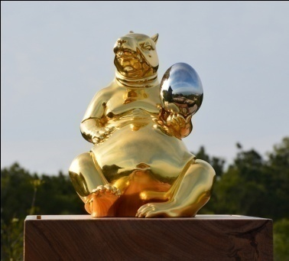
Work Title: Is It Mine?
Medium: bronze、gold、stainless steel
Dimensions: L:37.5cm/W:41.5cm/H:38cm
Date:2013-2015

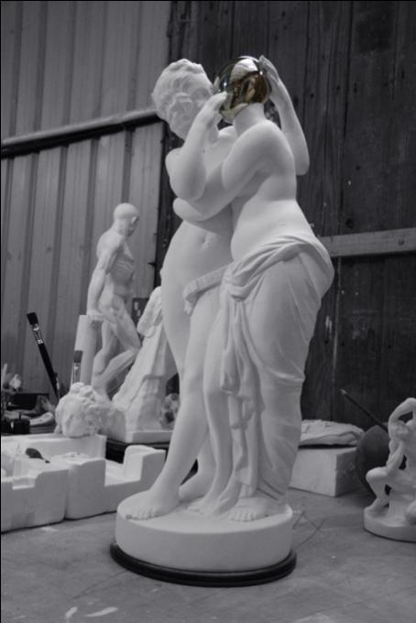
Work Title: Kissing
Medium: bronze、stainless steel
Dimensions: L:34cm/W:29cm/H:80cm
Date:2015

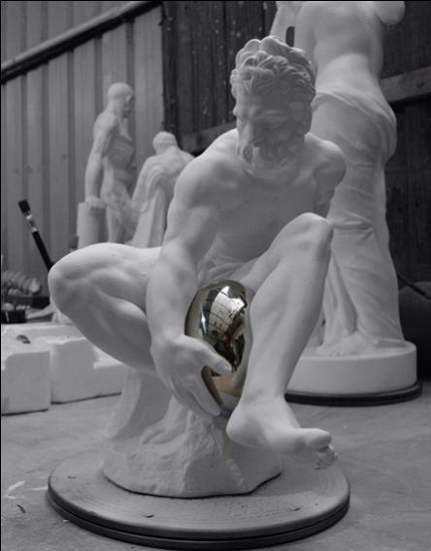
Work Title: Belonging
Medium: bronze、stainless steel
Dimensions: L:28cm/W:37cm/H:42cm
Date:2015

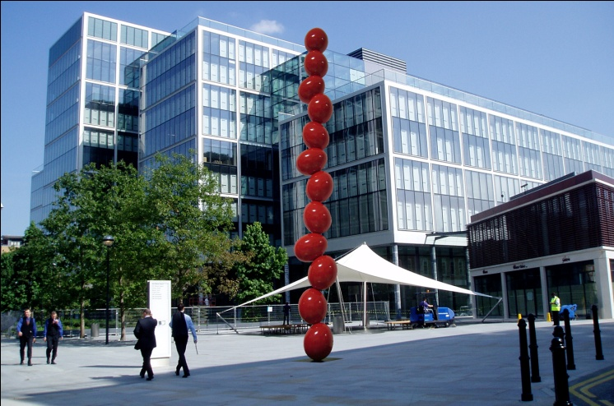
Work Title: Bring Out No.1
Medium: stainless steel
Dimensions: L:12cm/W:12cm/H:100cm
Date:2009
Collection: Art organization London

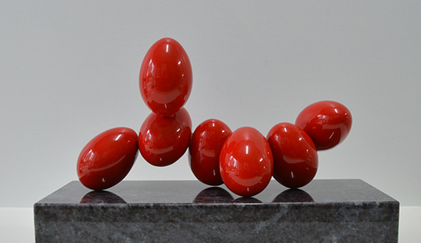
Work Title: Bring Out No.2
Medium: stainless steel
Dimensions: L:23.5cm/W:9cm/H:18cm
Date:2009

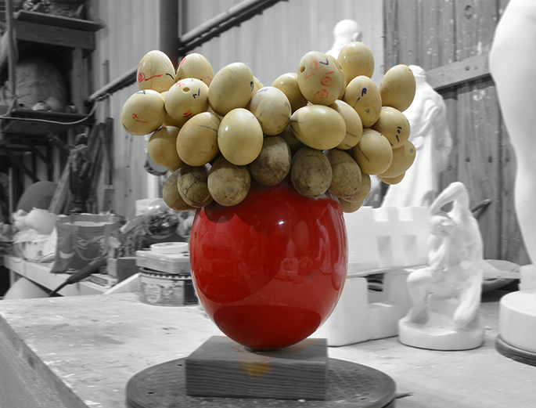
Work Title: Loving
Medium: resin
Dimensions: L:33cm/W:24cm/H:40cm
Date:2010-present

To further explore this microscopic physical event, Wenqin Chen is capturing it visually in two dimensional works.Paintings of bright colors bring rich emotion and vitality to the canvas. These representative works include: A series of "Miraculous Journey" (2010) and "Stories of Story" (2015- present). These arcs of simplicity expressed with color diversity are not pre-designed. They are a visual representation through the process of comprehending and elaborating on the vastness of life.

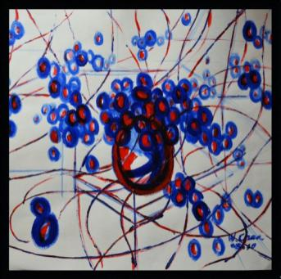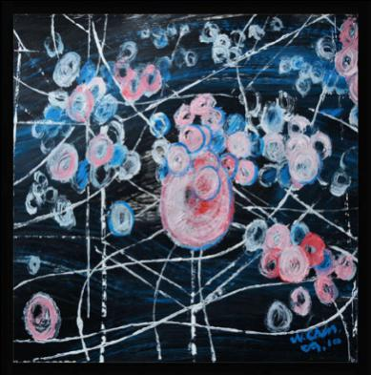
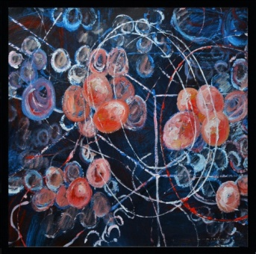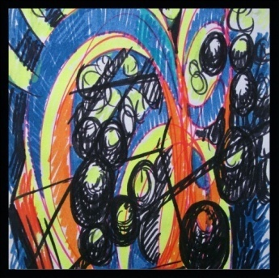
Work Title: Miraculous Journey
Medium: oil on canvas
Dimensions:L:200cm/W:200cm
Date:2010

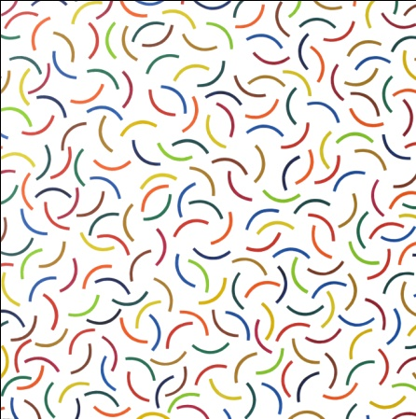
Work Title: Stories of Story
Medium: oil on canvas
Dimensions: L: 200cm/W: 200cm
Date: 2015

"Everything has life, life is everywhere." This is the truth Wenqin Chen consistently explores in his works. Along with this truth he continues to make works which will stimulate our psychological and physiological reactions.

