LUCREZIA TESTA IANNILLI
ART DIRECTOR

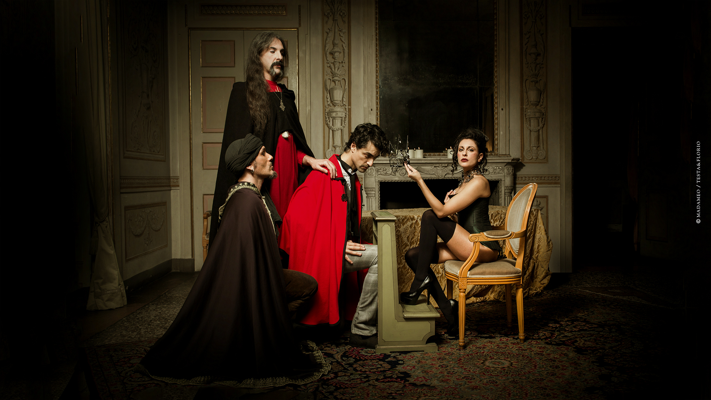

REVELANT YOUNGEST EXPERIENCE

BULLE, Fribourg – SWISS 1994 (Oct/Dec)
First successful restaurant managment experience in the renowned italian restaurant “Chez Angelo au Moleson” in Fribourg Swizerland.

MONTREAL, - CANADA 1995 (Jan/July)
Successfully graduated federal horse riding instructor / breeding
and training manager at the Federal Equestrian Academy of Quebec (FEC), Canada.

VOGHERA/BELLUNO/SIENA/ROME, Italy 1995/1999
Federal instructor, judge, brader, trainer, manager for the industry in horsemanship and riding
competitions, for several renomates private stables.

BELO HORIZONTE, Brasil 1999 (Apr/Dec) Teather events manager for a communications & marketing
agency as weel as responsible for the floor arrangement of the famous jazz Bar Cafe com Letras located in the Savassi area, one of the most vibrant club in the City centre of BH.

ROME, ITALY 2001/2008

- (Jan/Dec 2001) Manager e barman: responsible for the stock and waiting stuff in few pubs in the city center in Rome, names include “The Duke” in Pantheon, “Shamrock” in the
Colisseum and “Fiddler’s” at Piramide.

- (Jan 2002/Jan 2003) Manager: responsible for the stock storage, waiting staff, accounting, musicians, and floor plan in the summer space “Capannelle” of the renomate Restaurant
“No Stress Brasil”.

- (Feb 2003/Mar 2005) Co-Owner of the LUAL Ltd, an agency for intermediation and
comunication of art, music and management business.

- (2006) Course and succesfully exams for the Food and Beverage license,
in the Chamber of Commerce of Rome.

- (Sep 2007/Dec 2009) Co-Owner & Art Director of the BIUTI sas, an organic Tea Room and Library: responsible for the musical and cultural events management e art strategy, public relations service, musicians coordinations, food and tea stock.

LONDON, UK 2009/2010

- (Mar/May 2009) Dely and art shop responsible at the Famous italian chain
“Carluccio’s”, Spiatlfield Market.

- (Jan/Sep 2009) Chef assistant and responsible for the public relations stock in
the organic italian restaurant “Stori Dely” in the vibrant area of Brick Lane.

- ( Jan 2010/Dec 2011) Owner e Art Director of the Milonga &Tango School,
“Milonga Bohemienne” in the heart of Hackney.

- (Oct 2011/Jan 2012) Responsible for website/social network/public relations and viral strategy of comunication of the tango dance company&school
“Milonga della Stazione” in Rome.

PALERMO/MILAN/ROME/VENICE, ITALY 2011/2014

AGOUST 2011
DIRECTION / MAQUEDA BLAZE VIDEO
http://www.youtube.com/watch?v=QyB5cnXMCRg&feature=share
http://www.siciliaweek.it/index.php?option=com_k2&view=item&id=506:video-di-lucrezia-testa-iannilli&Itemid=28

NOVEMBER/DECEMBER 2011
PRODUCTION & ART DIRECTION BOHEMIAN CIRCUS 1812 EVENT
http://www.youtube.com/watch?v=syyhpDuX0v0
http://www.youtube.com/watch?v=H_Irmfd-p-Y&feature=related
http://www.facebook.com/events/211393745602257/

JANUARY 2012
OFFICIAL OPENING VILLA BRUCSJ alcova/atelier
http://www.facebook.com/pages/Villa-Brucsj/255604907858752
http://vimeo.com/38537990

JANUARY 2012
GRABRIELLA GRASSO & FRIENDS CONCERT / OFFICINE ZO - CATANIA
http://www.youtube.com/watch?v=musflpBa7gc

FEBRUARY 2012
PROMOTION / COPYWRITING & ART DIRECTION CITY ASSEMBLY:
http://allevents.in/Palermo/LA-RENAISSANCE----ASSEMBLEA-CITTADINA/127841274005833
http://www.facebook.com/events/127841274005833/

FEBRUARY 2012
GUEST at DECADENZA EVENT / VENICE:
http://vimeo.com/46024841 - official video.
http://www.veneziatoday.it/eventi/discoteche/Decadenza-Party-al-Teatro-San-Gallo.html
http://www.facebook.com/media/set/?set=a.399548403392534.111767.210204075660302&type=1

MARCH 2012
BODHRAN TEACHER at the school:
http://www.labottegadellepercussioni.it/bottega/insegnanti/51

APRIL/MAY 2012 – VIRAL STRATEGY/COPYWRITING/ARTDIRECTION/PROMOTION
ALESSANDRO ALA CITY ELECTION at the Consiglio Comunale / Palermo:

http://www.youtube.com/watch?v=DJAjxNearrM&feature=share
PRELUDIO D'ARTE. UN SABATO D'AUTORE Parte prima
http://www.youtube.com/watch?v=TAFuIW6rEPk&feature=share
PRELUDIO D'ARTE. UN SABATO ELETTRONICO parte seconda
http://www.youtube.com/watch?v=gK_hPpWPmV4&feature=share
PRELUDIO D'ARTE. UN SABATO D'AUTORE parte terza
http://www.youtube.com/watch?v=6lnRG8NC6TI&feature=share
PRELUDIO D'ARTE.. UN GIOVEDI D'AUTORE# parte 4

APRIL 2012
MANAGEMENT and PERFORMANCE at:
L’UOMO DARGENTO vs IL GENIO DI PALERMO READING
TEATRO GARIBALDI APERTO
http://allevents.in/Palermo/238235876274287

APRIL/AGOUST 2012
SOCIAL MEDIA and PUBLIC RELATION MANAGER
TEATRO GARIBALDI APERTO GROUP
http://teatrogaribaldiaperto.wordpress.com/
http://www.facebook.com/groups/250281011737425/

SEPTEMBER/DECEMBER 2012
MANAGMENT/ART DIRECTION/PROMOTION
Boudoir Manouche / FIRST GIPSY JAZZ & SECRET CLUB
http://www.facebook.com/BoudoirManouche?ref=hl
http://www.balarm.it/eventi/9262-boudoir-manouche.asp

SEP/DEC 2012
ART DIRECTION AND PROMOTION
MOUSTACHE! EVENT
http://www.facebook.com/groups/537787782913079/

MAY/JULY 2013-2014
ARTD DIRECTION/MANAGMENT/COPYWRITING/PROMOTION

LUNA PARK+TIGERS IN THE CITY EVENTS
http://www.testaflorioagency.tumblr.com
THE BOHEMIAN GALLERY
http://www.facebook.com/groups/628875907147826/
THE LOTOS
http://www.facebook.com/pages/The-Lotos/1394100487501079?fref=ts
M.O. SECRET SOCIETY & EVENTS | Milan. Ibiza. Venice. Rome.
https://www.facebook.com/pages/Lucrezia-Testa-Iannilli/550581721651921?fref=ts

INDEX OF PLACES:

- Bohemian Photografer Gallery – Palermo 2013/2014
- Boudoir Manouche – Palermo/Toulose 2012/2013
- Bohemian Circus – Palermo 2012 bohemiancircus.com
- Teatro Garibaldi Aperto – Palermo 2012 teatrogaribaldiaperto.com
- Milonga della Stazione – Roma 2011 milongadellastazione.com
- Boys Tango Club – London 2010 hackneytango.com
- Rendez vous des Amì – Paris 2010
- Stori Dely – London 2009 storydeli.com
- Carluccio’s – London 2009 carluccios.com
- Strada – London 2009 strada.co.uk
- BiuTì sas – Rome 2007/2008 biuti.it
- Profumi di Sicilia – Rome 2006
- Lual srl – Rome 2003/2005
- No Stress Brasil – Rome 2002
- BlackD.Pub/Shamrock/Fiddler’s - Rome 2001 shamrockirishpub.it
- Cafè Com Letras – Belo Horizonte 1999 cafecomletras.com.br
- Academie Equestre Mont St Hilaire – Montreal 1995
- Chez Angelo au Moleson – Bulle 1994

LANGUAGES:
Iatalian (Mother Toungue)
French (Fluent)
Portuguese (Fluent)
English (Basic)
Spanish (Basic)

PERSONAL DETAILS:
Nationality: Italian
Date of Birth: 11/12/1977
Marital Status: Single

INTERESTS:
Photography, Historic and Charming Location, Music, Art, Interior Design, Public Relations, Literature, Antiques, Tango, D’essai Cinema, Subcultures, Food and Vine, Tea, Horse Riding & Polo, Theatre, Circus, Sicily, Body Building, Travel, Healty Life Style, Architecture, Dress Code Events, People.

SOCIAL MEDIA
mail | lucreziatestaiannilli@gmail.com
website | bohemiancircus.com
linkedin | linkedin.com/profile/edit?trk=tab_pro
flickr | flickr.com/photos/lucreziatestaiannilli
facebook | facebook.com/lucrezia.iannilli
twitter | twitter.com/#!/lucreziaTJ
tumblr | bohemiancircus.tumblr.com
pinterest | pinterest.com/lucreziatj
wordpress | lucreziatestaiannilli.wordpress.com/
stumbleupon | stumbleupon.com/stumbler/bohemiancircus
about.me | about.me/lucreziatestaiannilli
scoop | scoop.it/u/lucrezia-testa-iannilli
youtube | youtube.com/user/lucreziatestaiannilli
behance | behance.net/bohemiancircus

LUCREZIA TESTA IANNILLI

0039 | 349 8798964 Rome/Palermo
0044 | 779 4438539 London

