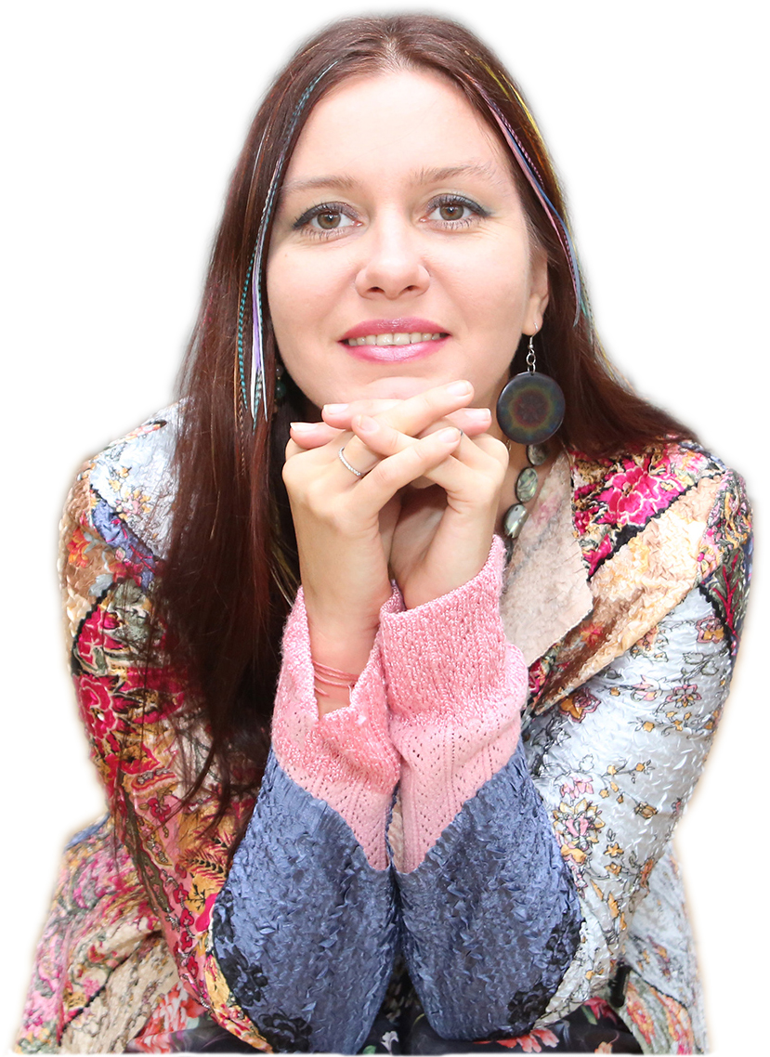
EKATERINA ABRAMOVA is an artist, specializing in painting and graphic arts in mixed as well as traditional techniques using oil, acrylic, markers, etc.
Although being a multifaceted artist, her style could be described as going in two major directions: the 21st century Post-Expressionism, and Spiritual Ornamental paintings drawn on symbolic folk art of various peoples, most notably on Russian and Indian mythology. Born in 1979 in Moscow, she graduated from an art school with honors and continued her studies at the Vasnetsov College of Fine Arts, Moscow. In 2007 she received her MFA from the I.E. Repin State Academy of Fine Arts, St. Petersburg, Russia. Her numerous awards include Gold Medal “250th anniversary of the Russian Academy of Arts,” Gold Medal “National Treasure” of the International Charity Fund “Philanthropists of the Century”, citation from the Russian Academy of Fine Arts for the participation in the exhibition dedicated to the 250th anniversary of the Academy, the Peacekeeper Fund Medal, among others. She was nominated for the State Presidential Scholarship in the Arts. She is a member of the Union of Russian Artists, Art Fund International, Creative Union of Professional Artists, Art Indulge Foundation.
In 2014, she was awarded an International Artist Residency in Hyderabad, India, organized by the State Fine Art Gallery and Kalanirvana Foundation, to represent Russia among 20 other artists from all over the world; as well as similar artist residency in Goa Chitra Museum, Goa, India.
And in 2015, she has been awarded a 3-month International Artist Residency, curated by Eileen Kaminsky Foundation at Mana Contemporary Art Complex in Jersey City, NJ, during which she will make 10 paintings of her new series Placenta starting September 2016.
Among her most recent exhibitions are: Miami River Art Fair, Miami, Florida, December 2015; Artnado Art Fair, West Palm Beach, Florida, USA, November 2015; Exhibition “Expressions of Color” at Gateway Arts Center, New York City, USA, May 2015; Exhibition “Take Your Breath Away” at the Victoria Space, Art Factory, Paterson , NJ, USA, June 2015; Kolkata Art Biennale, Kolkata, India, April 2015; Exhibition ArtExpo New York, New York City, USA, April 2015; Art India Festival, Mumbai, India, November 2014; Exhibition Golden Age, Russian Cultural Centre, Berlin, Germany, November 2014; Exhibition Innovation of Color, Westside Park Art Gallery, New York City, USA, October 2014; Woman’s Academy, Moscow, September 2014; Exhibition Art Through Light II at the State Gallery of Fine Art, Hyderabad, India, September 2014; Exhibition On The Right Way, Central Artist’s House, Moscow, September 2014; Exhibition ArtExpo New York, New York City, USA, April 2014; Exhibition Artistry at Artery Fine Art Gallery, Chicago, USA, February 2014; Art Cocktail Exhibition at D.E.V.E. Gallery, Bruges, Belgium, November 2013.

She has had numerous personal exhibitions of her art all over Europe, India, China, and USA.
Her works are in private collections in UK, France, Germany, Russia, Belgium, Finland, Italy, Switzerland, China, India, and USA.
She lives and works in New York.

EDUCATION
1996-1999 Vasnetsov College of Fine Arts, Moscow, Russia
2007 I.E. Repin Academy Of Fine Arts, St. Petersburg, Russia

SOLO EXHIBITIONS

2015 Exhibition Expressions of Color, The Gateway Art Center. New York, NY, USA
2014 Woman’s Academy, Moscow, RUSSIA
2013 The Nefta Gallery. Voronezh, RUSSIA
2013 Galaxy. Guttenberg, NJ, USA
2012 Russian Center of Science and Culture. New Delhi, INDIA
2011 Embassy of India in Russia. Moscow, RUSSIA
Fusion Art Gallery. Moscow, RUSSIA
2010 Тilting Art Gallery. Pune, INDIA
2009 Open Air Gallery. Goa, INDIA
Cultural Center Rossinka. Moscow, RUSSIA
2008 Art Fund International. Moscow, RUSSIA
The German House. Moscow, RUSSIA
Castle Burg Hohenklingen. SWITZERLAND
Embassy of Russian Federation in Switzerland. Bern, SWITZERLAND
2007 Landrasampt. Konstantz, GERMANY
2006 German House. Moscow, RUSSIA
Elena Art Gallery. Central House of Artists, MOSCOW
2005 Bezh Gallery. Moscow, RUSSIA
2003 Art Business Gallery. St. Petersburg, RUSSIA
2001 Arte Vita Gallery. Moscow, RUSSIA
1999–2001 Embassy of Germany in Russia. Moscow, RUSSIA
2000 German-Russian House. Moscow, RUSSIA
Embassy of Finland in Russia. Moscow, RUSSIA
1998 House of People’s Friendship. Moscow, RUSSIA

SELECTED GROUP EXHIBITIONS
2015 Miami River Art Fair. Miami, FL, USA
Artnado Art Fair. West Palm Beach, FL, USA,
Exhibition Take Your Breath Away at the Victoria Space, Art Factory. Paterson, NJ, USA,
ArtExpo New York. New York, NY, USA
Kolkata Art Biennale. Birla Academy. Kolkata, INDIA
2014 Art India Festival. Nehru Centre. Mumbai, INDIA
Exhibition Golden Age. Russian Cultural Centre. Berlin, GERMANY
Exhibition Innovation of Color. West Park Art Gallery. New York, NY USA
Exhibition On The Right Way. Central Artist’s House. Moscow, RUSSIA
Tumen International Arts Festival. Tumen, CHINA
Exhibition Personal & Universal, Merseles Studio. Jersey City, NJ, USA
Art Expo NY. New York City, USA
Exhibition Artistry at Artery Fine Art Gallery. Chicago, USA
2013 Art Cocktail Exhibition at D.E.V.E. Gallery. Bruges, BELGIUM
Art Biennale. Moscow, RUSSIA
Exhibition Art@Rasia at D.E.V.E. Gallery. Moscow, RUSSIA
2012 Liber Arte Foundation. Balaton Lake, HUNGARY
State Gallery of Fine Arts. Hyderabad, INDIA
Hungarian Information and Cultural Centre. Delhi, INDIA
Visual Art Gallery. London, UK
2011 A Journey Beyond the Three Seas, Roerich Museum. Moscow, RUSSIA
2010 Art-Yar Gallery. Moscow, RUSSIA
International Exhibition Eros 2010. Moscow, RUSSIA
2009 Arts Festival Traditions and the Present, Manezh. Moscow, RUSSIA
International Exhibition Eros 2009. Moscow, RUSSIA
2008 Society “Face”, Exhibition Family and Creativity, Central House of Artists. Moscow, RUSSIA
Art-Club Gallery, Central House of Artists. Moscow, RUSSIA
Orthodox Cultural Center. Moscow, RUSSIA
2007 Bis Gallery, Manezh. Moscow, RUSSIA
Exhibition Academic School, dedicated to the 250th anniversary of the Russian Academy of Fine Arts, Maliy Manezh. Moscow, RUSSIA
Tretyakov State Gallery. Moscow, RUSSIA
Awakening, Heritage State Exhibition Museum. Moscow, RUSSIA
Relics of Moscow Region, Moscow Region Gallery. Moscow, RUSSIA
Award Winner at the Exhibition Philanthropists of the Сentury, Tretyakov State Gallery. Moscow, RUSSIA
2006 Moscow and Moscovites, Union of Russian Artists’ Exhibition Center. Moscow, RUSSIA
Award Winner at International Youth Forum Exhibition. Moscow, RUSSIA
2005 Series of Exhibitions of Contemporary Russian Artists. ITALY
2004 Cultural Center. Arras, FRANCE
Royal Academy of Arts. Stockholm, SWEDEN
2002 Art Club, Central House of Artists. Moscow, RUSSIA
2001 Creative Union “NUR,” Central House of Artists. Moscow, RUSSIA
1999–2000 Bagira Art Gallery. Moscow, RUSSIA
1998–2000 Exhibition Albatros. Moscow,
1999 Exhibition Vakhtangov. Moscow, RUSSIA
1997 Gallery expositions Aktsia, Central House of Artists. Moscow, RUSSIA
Club Des Arts Gallery. Moscow, RUSSIA
1996 City Gallery. Sergiev-Posad, Moscow, RUSSIA

AWARDS AND GRANTS
International Art Residency. Eileen S. Kaminsky Family Foundation at Mana Contemporary. Jersey City, NJ, USA (2015-2016)

The Medal “Talent and Mission (Vocation)” issued by Worldwide Charitable Alliance Peacemaker, MOSCOW, RUSSIA (2014)

International Art Residency at Goa Chitra Museum. Goa, INDIA (2014)

International Art Residency. Kalanirvana Foundation. Hyderabad, INDIA (2014)

Gold Medal “National Treasure” of the International Charity Fund Philanthropists of the Century, Moscow RUSSIA (2012)
The Gold Medal 250th Anniversary of Russian Academy of Arts, St. Petersburg, RUSSIA (2007)
Honorable Citation by the Russian Academy of Fine Arts, Moscow, RUSSIA (2007)

SELECTED BIBLIOGRAPHY
2014 Examiner.com. ArtExpo New York Review by Lisa Dubois (April 8, 2014)
Rasia.com. ArtExhbition Review. Moscow, RUSSIA (June 18 2014)
The Hindu, Ambassadors of Art. Hyderabad, INDIA (February 2014)
Gomnantak Times. Goa, INDIA (February 19, 20014)
Herald Cafe. Goa, INDIA (February 15, 20014)
2012 Beyond Icons by Elizabeth Rogers, art historian. XXI Russian Gallery Magazine. Moscow, RUSSIA (Issue 5, 2012)
RIA Novosti. Art Review by Dmitri Kosyrev. Moscow, RUSSIA (December 2012)
The Hindustan Times, Art Revew. Mumbai, INDIA (April 26, 2012)
2011 Voronezh Pulse. Voronezh, RUSSIA (Issue December 2011 – January 2012)
2010 The Indian Express, Mumbai, INDIA, (April 2010)
2008 Art Encyclopedia. Moscow, RUSSIA (Issue 4, 2008)
Cultural Life. Konstanz, GERMANY (No. 8 (13), 2008)
2007 Art of Russia – Russian Art Guide. Moscow, RUSSIA (Issue 6, 2007)

Contacts:
Tel.: +1 201-238-0087 / +1 201-484-0174 (New York)
+7 916-714-93-13 / +7 495-543-30-85 (Moscow)
+91 99-70-371317 (India)
Email: artabramova@gmail.com
FB: Ekaterina Abramova Artist
Skype: artikatya
www.artabramova.com

